FleetControl
Design Document
Paul M. Summitt
312 Proctor Drive
Columbia, MO 65202 USA
paulmsummitt@outlook.com
573-544-8635
Last edited: 30 January 2026
Copyright © 2024-26 Paul M. Summitt]. All rights reserved.
No part of this publication may be reproduced, transmitted, transcribed, stored in a retrieval system, or translated into any language, in any form or by any means, electronic, mechanical, photocopying, recording, or otherwise, without prior written permission from Paul M. Summit.
All copyright, confidential information, patents, design rights and all other intellectual property rights of whatsoever nature contained herein are and shall remain the sole and exclusive property of Paul M. Summitt. The information furnished herein is believed to be accurate and reliable.
However, no responsibility is assumed by Paul M. Summitt for its use, or for any infringements of patents or other rights of third parties resulting from its use.
The Paul M. Summitt name and Paul M. Summit logo are trademarks or registered trademarks of Paul M. Summitt.
All other trademarks are the property of their respective owners
Design Document
Paul M. Summitt

FleetControl
Version: 0.3 Revision Date 30Jan2026

Executive Sponsor
[Name] | [Email] | [Telephone]
Signature |  | Date

Technology Sponsor
[Name] | [Email] | [Telephone]
Signature |  | Date

Project Manager
[Name] | [Email] | [Telephone]
Signature |  | Date

Security Officer
[Name] | [Email] | [Telephone]
Signature |  | Date

Table of Contents
1 EXECUTIVE SUMMARY 7
1.1 Purpose of this document 7
1.2 Identification 7
1.3 Scope 7
1.4 Relationship to Other Plans 7
1.5 Methodology, Tools, and Techniques 8
1.6 Policies, Directives and Procedures 8
2 DESIGN OVERVIEW 9
2.1 Background Information 9
2.2 System Evolution Description 9
2.3 Current Process 9
2.4 Proposed Process 9
2.5 Technology Forecast 9
2.6 Constraints 9
2.7 Design Trade-offs 9
2.8 User Characteristics 10
2.8.1 User Problem Statement 10
2.8.2 User Objectives 10
3 SYSTEM ARCHITECTURE 11
3.1 Hardware Architecture 11
3.2 Software Architecture 11
3.3 Communications Architecture 11
4 DATA DESIGN 12
4.1 Database Management System Files 12
4.2 Non-Database Management System Files 12
5 DETAILED DESIGN 13
5.1 Hardware Detailed Design 13
5.2 Software Detailed Design 14
5.2.1 Module [X] 14
5.2.2 Module [X] 14
5.3 Communications Detailed Design 15
6 EXTERNAL INTERFACE DESIGN 16
6.1 Interface Architecture 16
6.2 Interface Detailed Design 16
7 HUMAN-MACHINE INTERFACE 19
7.1 Interface Design Rules 19
7.2 Inputs 19
7.3 Outputs 19
7.4 Navigation Hierarchy 19
7.4.1 Screen [x.1] 19
7.4.2 Screen [x.2] 20
7.4.3 Screen [x.3] 20
8 SYSTEM INTEGRITY CONTROLS 21
9 APPENDIX A 22
9.1 Requirements Traceability Matrix 22
9.2 Packaging and Installation 22
9.3 Design Metrics 22
9.4 Glossary of Terms 22

Document History
Paper copies are valid only on the day they are printed. Contact the author if you are in any doubt about the accuracy of this document.
Revision History
Revision Number | Revision Date | Summary of Changes | Author
0.1 | 18Aug2024 | Initial Documentation | Paul M. Summitt
0.2 | 20Jan2026 | Update Document | Paul M. Summitt
0.3 | 30Jan2026 | Format Document | Paul M. Summitt
Reference Documents
Please see the following documents for more information:
Document Name | Version | Author
Distribution List
This document has been distributed to:
Name |  |  | Position | Company | Action

Executive Summary

Executive Summary for the FleetControl Web Project
FleetControl is an innovative web-based solution designed to streamline vehicle fleet management operations for individuals and businesses of all types and sizes. Our project aims to develop a comprehensive platform that facilitates real-time tracking, efficient resource allocation, and enhanced communication among fleet operators and their workforce.

Project Objectives
- Enhance Fleet Visibility: Implement GPS and telematics technologies to provide real-time location updates and performance metrics, enabling users to efficiently manage their assets.
- Optimize Resource Allocation: Utilize advanced analytics to ensure optimal routing and scheduling, reducing fuel consumption and operational costs.
- Improve Communication: Integrate communication tools for seamless interaction between drivers and dispatch, ensuring prompt responses to any on-ground issues.
- User-Friendly Interface: Design a highly intuitive user web interface that accommodates varying levels of technology proficiency among users.

Key Features
- Real-Time Vehicle Tracking: Users can monitor the location and status of vehicles at any given moment.
- Route Optimization: Automatic suggestions for the best routes based on traffic data to minimize delays.
- Maintenance Alerts: Notifications for scheduled vehicle maintenance to enhance safety and efficiency.
- Reporting Dashboard: Centralized analytics dashboard for monitoring performance metrics and generating reports.

Project Timeline
The FleetControl project is scheduled for a development cycle that will include the following phases:
- Requirement Gathering and Analysis
- Design and Development
- Testing and Quality Assurance
- Launch and Feedback Collectiion

Expected Outcomes
By implementing the FleetControl Web project, we anticipate significant improvements in operational efficiency, cost savings related to fleet management, and enhanced user satisfaction. This solution aims to empower individuals and businesses to make data-driven decisions, thereby maximizing both productivity and profitability.

Conclusion
The FleetControl web project represents a pivotal advancement in fleet management technology, making it an essential investment for businesses looking to improve their operational capabilities. Through innovative features and a user-centric design, FleetControl positions itself as a leader in the fleet management sector.

Purpose of this document
The purpose of the FleetControl Design Document is to provide a comprehensive framework detailing how the FleetControl system will be constructed, ensuring all stakeholders have a clear understanding of the project’s technical specifications and design decisions. This document serves as a blueprint that translates the requirements outlined in the Requirement Specifications into actionable guidelines for developers and project managers.

Key Objectives of the Design Document
- System Architecture: Outline the top-level architecture of the FleetControl system, including its modular components and their interactions.
- Technical Specifications: Detail the specific hardware, software, and communication protocols necessary to implement the solution effectively.
- User Interface Design: Describe the design and functionality of user interfaces, ensuring they are intuitive and user-friendly for various user groups.
- Integration Points: Identify potential integration points with existing systems and external services to ensure seamless operation.
- Development Guidelines: Provide coding standards and practices to be adhered to throughout the development lifecycle.

Intended Audience
The intended audience for the FleetControl Design Document includes:
- Developers: Software engineers and developers who will use this document to implement the system based on the outlined specifications.
- Project Managers: Individuals responsible for overseeing the project, ensuring timelines and budgets are adhered to while maintaining quality.
- Quality Assurance Team: QA professionals who will use the design document to formulate their testing strategies and ensure all requirements are met.
- Stakeholders: Business stakeholders and decision-makers who require insight into the system’s design to align it with organizational goals.
- Maintenance Teams: Future technical support personnel who will benefit from understanding the system architecture and components for ongoing maintenance.
By addressing both technical and organizational needs, the FleetControl Design Document serves as a vital resource to facilitate effective communication and collaboration among all parties involved in the project. This ensures the final product aligns with business objectives and user expectations while adhering to best practices in system design and development.

System and Software Identification

System Identification
- Identification Number: FC-SYS-001
- Title: FleetControl System
- Abbreviation: FC
- Version Number: 1.0
- Release Number: R1

Software Identification
- Identification Number: FC-APP-002
- Title: FleetControl Web Application
- Abbreviation: FC-Web
- Version Number: 1.0
- Release Number: R1

Applicable Standards
The following standards are relevant to the design of the FleetControl System and its accompanying software:
- ANSI (American National Standards Institute):
  - ANSI/ISO/IEC 25010: Systems and Software Engineering – Systems and Software Quality Requirements and Evaluation (SQuaRE) – System and Software Quality Models.
- ISO (International Organization for Standardization):
  - ISO 9001: Quality Management Systems – Requirements.
  - ISO/IEC 12207: Software Life Cycle Processes.
- IEEE (Institute of Electrical and Electronics Engineers):
  - IEEE 829: Standard for Software and Systems Test Documentation.
  - IEEE 1016: Recommended Practice for Software Design Descriptions.
  - IEEE 1233: Guide for Developing System Requirements Specifications.
- Agile Alliance:
  - Agile Manifesto: Principles of Agile Software Development that guide iterative design and development processes.
By adhering to these standards, the FleetControl Design Document aims to ensure quality and reliability throughout the development and implementation lifecycle, aligning with industry best practices and regulatory requirements.

Scope
The scope establishes the boundaries of the design document and should describe features outside of the scope, for example, if certain requirements were not included in the design due to budgetary or time constraints.
Includes
Initial Website Development with PHP and MySQL

Excludes

Relationship to Other Plans
Describe this document’s relation to other plans, such as:
- FleetControl Data Dictionary Version 0.3
- Functional Requirements [version]
- Configuration Management Plan [version]
- Software Quality Assurance Plan [version]

Methodology, Tools, and Techniques
The initial development work of the FleetControl Web project is being done using PHP and MySQL on the local development machines. As the project progresses, both the Website and the database will be moved to a development server in-house. Later the FleetControl Web project will be migrated to Azure Web apps. .

Policies, Directives and Procedures
At this point in time no constraints or requirements are identified as being placed on this document by policies, directives, or procedures.

Design Overview
Provide a brief introduction to the proposed system. Outline how the system will fit into the company’s business and technology environments, and discuss any strategic issues if appropriate.

Background Information
In 1998, while working for KAIT-TV in Jonesboro, Arkansas, then principle designer and developer was asked by the station’s news director to develop some way to help keep track of expense of the various station vehicles. Using Microsoft Access Developer 2000, an application was developer that kept track of the expenses associated with each vehicle. .

System Evolution Description
[Optional] Describe how to migrate the existing system(s) to a more efficient system, or alternately moving an existing system to a future implementation.

Current Process
[Optional] Describe the current processes that are in place (if applicable). This may help place the overall design in context.

Proposed Process
[Optional] Describe the proposed process. Reference any supporting documents, if relevant.

Technology Forecast
[Optional] Outline the emerging technologies that are expected to be available in a given timeframe(s), and how they may impact the future development of system the architecture.

Constraints
Detail any constraints that are placed upon the system design, such as schedules, costs, or technical constrains, such as the company’s commitment to a specific development platform or programming language.

Design Trade-offs
Discuss the tradeoffs involved with the design chosen and the reasons for your choices. For example, an increase in security controls will likely entail a decrease in ease-of-use; an increase in the flexibility of a system typically entails a decrease in the simplicity of that system. For this reason, the designer must decide to put a higher value on some attributes over others. Some areas to consider include:
- Flexibility
- Interoperability
- Performance
- Reliability and robustness
- Usability

User Characteristics
Describe the features of the user community, and their proficiency with software systems etc.

User Problem Statement
Describe the major problem(s) experienced by the user community.

User Objectives
Outline the users’ objectives and requirements for the new system. Where appropriate, include a "wish list" of desirable features.

System Architecture
Describe the system and/or subsystem(s) architecture for the project. Discuss the general architectural decisions that have been approved. Include a graphical representation, where appropriate.

Hardware Architecture
Describe the system hardware architecture and indicate whether the processing system is distributed or centralized. List and describe the hardware modules with and diagrams showing the connectivity between the modules. If possible, identify the type/number/location of servers, workstations, processors, backup systems, output devices, etc.

Software Architecture
Describe the overall system software and organization. List and describe the software modules (i.e. including functions, subroutines, or classes), programming languages, and development tools.
Describe all software required to support the system, and specify the physical location of all software systems. Identify database platforms, compilers, utilities, operating systems, communications software, etc.
- Diagrams should map to the Functional Requirements Document’s data flow diagrams.
Provide diagrams that illustrate the segmentation levels down to the lowest level. Include names and reference numbers for all features on the diagrams. Include a narrative that expands on and enhances the understanding of the functional breakdown.

Communications Architecture
Describe communications within the system, such as Local Area Networks (LANs), buses, etc. Include the communications architecture(s) being implemented, such as X.25, Token Ring, etc.
Provide a diagram depicting the communications path(s) between the system and subsystem modules.

Data Design
This section outlines the design of the database management system (DBMS) and non-DBMS files associated with the system. For networks, detail the distribution of data and identify any changes to the logical data model that may occur due to software or hardware requirements.
- Provide a Data Dictionary showing data element name, type, length, source, validation rules, maintenance, data stores, outputs, aliases, and description. Attach as an appendix.

Database Management System Files
Describe how the database will be designed, including the following information, as appropriate:
- Logical model; provide normalized table layouts, entity relationship diagrams, and other logical design information
- DBMS schemas, sub-schemas, records, sets, tables, storage page sizes, etc.
- Access methods (such as indexed, via set, sequential, random access, sorted pointer array, etc.)
- Estimate the database file size or volume of data within the file, data pages, including overhead resulting from access methods and free space
- Definition of the update frequency of the database tables, views, files, areas, records, and sets
- Estimates on the number of transactions the database may have to process

Non-Database Management System Files
Describe all non-DBMS files including narratives on the usage of each file. Identify if the file is used for input, output, or both; identify temporary files; which modules read and write the file, etc.
- Identify record structures, record keys, indexes, and reference data elements within the records
- Define record length and blocking factors
- Define file access method, such as, index sequential, virtual sequential, random access, etc
- Estimate the file size or volume of data within the file
- Define the update frequency of the file; if appropriate, provide the estimated number of transactions per unit time, and the statistical mean, mode, and distribution of those transactions

Detailed Design
This chapter describes the proposed design in detail. Provide the necessary information for the development team to integrate the hardware components, write the software code, so that the hardware and software components will provide a functional product.
- Every design item should map back to the Functional Requirements Document. These should be captured in the Requirements Traceability Matrix.

Hardware Detailed Design
In this section, provide enough information for the developers to build and/or procure the system’s hardware.
- If this section becomes too lengthy, consider placing it in the Appendix or reference it in a separate document. Add additional diagrams, if necessary, to describe each component and its functions.
Include the following information (as applicable):
- Cable type(s) and length(s)
- Connector specifications
- Details of hardware items, such as monitors, printers, servers, I/O devices, and the relationship to each other
- Hard drive/floppy drive/CD-ROM requirements
- Memory and/or storage space requirements
- Monitor resolution
- Power input requirements for each component
- Processor requirements
- Signal impedances and logic states

Software Detailed Design
A software module is the lowest level of design granularity in the system. In this section, provide enough detailed information for the developers to write the source code for all modules in the system (and/or integrate COTS software programs).
For each module, provide the following information:
- Narrative introduction to each module, its function(s), the conditions under which it is used (called or scheduled), processing, logic, interfaces to other modules, interfaces to external systems, security requirements, etc.
- Graphical representation of the module processing, logic, flow of control, and algorithms, using charts, diagrams, flowcharts as appropriate
- Data elements, record structures, and file structures associated with module input and output
- Report layout
- For COTS packages, specify any call routines or bridging programs to integrate the package with the system and/or other COTS packages, such as DLLs (Dynamic Link Libraries)
Repeat this section for each module.

Module [X]
Provide a detailed description of each software module.

Processing
Provide a processing narrative for each module.
Explain the process by which each module interacts with other parts of the system, including other modules. Describe the data elements and data structures which provide input to each module, how the module transforms the data, and the data elements or data structures which are output.

Local data structures
Describe the local data structures.

Module [X]
Provide a detailed description of each software module.

Processing
Provide a processing narrative for each module.

Local data structures
Describe the local data structures.

Communications Detailed Design
Provide enough detailed information about the communication requirements to build and/or procure the communications components for the system.
- This section should provide enough detail to support the procurement of hardware for the system installation
Include the following information in the detailed designs (as appropriate):
- Details of servers and clients to be included on each area network
- Specifications for bus timing requirements and bus control
- Format(s) for data being exchanged between components
- Diagrams showing connectivity between components, data flow (if applicable), and distances between components;
- LAN topology

External Interface Design
External systems are any systems that are not within the scope of the system under development, regardless whether the other systems are managed by the development company or its client.
In this chapter, describe the interface(s) between the system under development (i.e. this system) and other external systems and/or subsystem(s).

Interface Architecture
Describe the interface(s) between the system being designed and other systems. Include the interface architecture(s) being implemented, such as wide area networks, gateways, etc. Provide diagrams showing the communications path(s) between this system and other systems.

Interface Detailed Design
Provide sufficient detail about the interface requirements for the development team to format, transmit, and/or receive data across the interface.
Include the following information (as appropriate):
- Data format requirements; if data must be reformatted before it is transmitted or after incoming data is received. Describe the tools and/or methods for the reformat process
- Specifications for hand-shaking protocols between systems; content and format of hand-shake messages, timing for exchanging these messages, and errors handling
- Format(s) for reports exchanged between the systems
- Graphical representation of the connectivity between systems, showing the direction of data flow
- Query and response descriptions

Describe the individual data elements that the interfacing entity(s) will provide, store, send, access, and receive, such as:
1) Names/identifiers
Data Element Name
Data Format/Length
Data Type
Definition
Non-Technical Name
Non-Technical Synonyms
Specifications
Synonyms
2) Range or enumeration of possible values (e.g. 0-99)
3) Accuracy and precision (number of significant digits)
4) Priority, timing, frequency, sequencing, and other constraints
5) Security and privacy constraints
6) Sources (setting/sending entities) and recipients (using/receiving entities)

Describe the data element assemblies (records, messages, files etc.) that the interfacing entity(s) will provide, store, and send, such as:
1) Names/identifiers
Technical Name, e.g., data structure name
Non-technical Names, e.g. synonyms
2) Data elements
3) Medium/structure of data elements/assemblies
4) Visual characteristics (e.g. layouts, fonts, icons etc)
5) Relationships among assemblies
6) Security and privacy constraints
7) Sources and recipients

Describe the communication methods that the interfacing entity(s) will use for the interface, such as:
1) Communication links/bands/frequencies/media
2) Message formatting
3) Flow control (e.g. sequence numbering)
4) Data transfer rate
5) Routing
6) Transmission services
7) Safety
8) Security and privacy considerations

Describe characteristics of the protocols that the interfacing entity(s) will use for the interface, such as:
1) Priority/layer of the protocol
2) Packeting
3) Legality checks, error control
4) Recovery procedures
4) Synchronization
5) Status, identification, and other reporting features
Where appropriate describe other characteristics, such as physical compatibility of the interfacing entity(s) (dimensions, tolerances, loads, voltages, plug compatibility, etc.)

Human-Machine Interface
Describe the Human Machine interface (i.e. user interface) relative to the user. Additional information may be added if the suggested headings are inadequate.

Interface Design Rules
Identify conventions and standards for designing the user interface.

Inputs
Identify the input media used by the user (i.e. operator) for providing information to the system, such as data entry screens, optical character readers, bar scanners, etc.
Identify the messages associated with operator inputs, including the following:
- Form(s) if the input data is keyed or scanned for data entry
- Access restrictions
- Security considerations

Outputs
Describe the system output design relative to the user. System outputs include reports, data display screens, query results, etc.
Identify the following, if appropriate:
- Access restrictions or security considerations
- Description of the purpose of the output
- Report requirements, including frequency for periodic reports
- Screen contents (provide a graphic representation of each layout. Define all data elements associated with the layout)

Navigation Hierarchy
Provide a diagram of the navigation hierarchy that shows how a user moves through the user interface.

FleetControl Website Sign-In Use Case
This use case defines how a registered FleetControl user signs in to the web application to access fleet management features. It covers the standard login flow, error conditions, and security considerations.
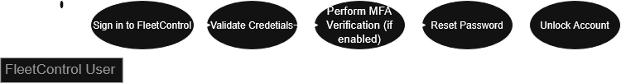
Figure 1: FleetControl User Sign in Use Case

Use Case Name
FleetControl User Sign-In
Primary Actor
Registered FleetControl user
Goal
Authenticate and gain secure access to the FleetControl dashboard.
Preconditions
- User has an active FleetControl account.
- User knows their registered email/username and password.
- FleetControl authentication service is available.
- If enabled, user has access to their MFA method (e.g., authenticator app, SMS).
Main Success Scenario
- User navigates to the FleetControl login page.
- User enters email/username and password.
- User selects Sign In.
- System validates credentials.
- If MFA is enabled, system prompts for MFA code.
- User provides valid MFA code within the allowed time.
- System creates an authenticated session and applies user roles and permissions.
- System redirects user to the dashboard (or last visited page).
- System records login event with timestamp and device/IP details.
Alternative Flows
- Incorrect Password
  - Steps 1–3 as above.
  - System rejects credentials and displays a non-specific error.
  - System increments failed attempt counter.
  - User may retry or select Forgot Password.
- Unknown Username/Email
  - Steps 1–3 as above.
  - System rejects credentials and displays a non-specific error.
  - No indication given whether the account exists.
- Account Locked
  - After N failed attempts within timeframe, system locks the account.
  - System notifies the user of lockout and provides unlock/reset instructions.
  - User must complete password reset or wait lockout duration.
- MFA Failure
  - Steps 1–4 succeed; MFA requested.
  - User enters invalid or expired code.
  - System rejects code, allows limited retries, then restarts sign-in or locks per policy.
- Password Reset
  - User selects Forgot Password.
  - System sends reset link to registered email.
  - User sets a new password meeting policy.
  - User repeats sign-in with new credentials.
- Session Timeout
  - If the session expires during sign-in, system prompts user to retry.
Postconditions
- On success: Authenticated session established; user is on the dashboard; login event logged.
- On failure: No session created; failed attempt recorded; user remains on login page with guidance.
Business Rules and Notes
- Enforce password complexity and rotation per policy.
- Lock account after N failed attempts within T minutes; auto-unlock after U minutes or via admin/reset.
- MFA required for privileged roles; optional or risk-based for others.
- Do not reveal account existence in error messages.
- Support SSO/OIDC where configured; skip password entry when IdP handles authentication.
- All authentication events are auditable.
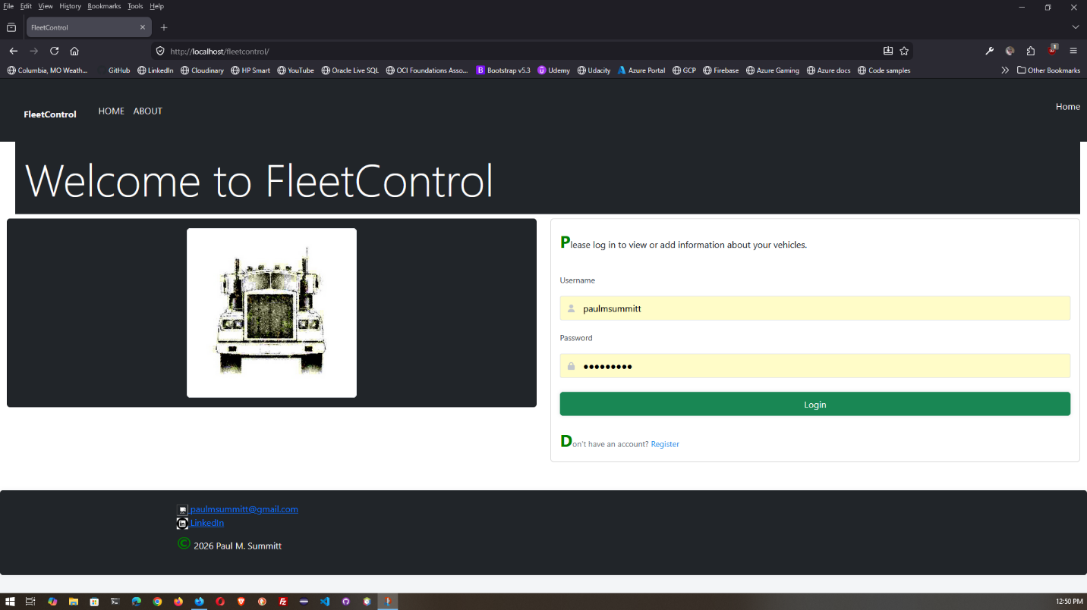
Figure 2: FleetControl Login Screen

FleetControl Website Register Use Case
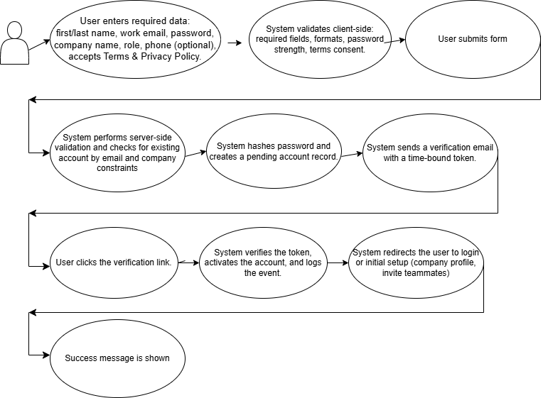
Use Case: User Registration (FleetControl)
Use Case ID
UC-REG-001
Description
Enable new users to create a FleetControl account to access vehicle tracking, maintenance scheduling, and analytics. Registration captures user and company details, validates input, and activates the account via email verification.
Actors
- Primary: Prospective User
- Secondary: Email Service, Identity Provider (IdP), Database, Fraud/Rate-Limit Service, Admin (for manual approvals if needed)
Preconditions
- User has internet access and a supported browser.
- Registration page is available.
- Email service and database are operational.
Main Success Scenario
- User opens the Register page.
- User enters required data: first/last name, work email, password, company name, role, phone (optional), accepts Terms & Privacy Policy.
- System validates client-side: required fields, formats, password strength, terms consent.
- User submits the form.
- System performs server-side validation and checks for existing account by email and company constraints.
- System hashes password and creates a pending account record.
- System sends a verification email with a time-bound token.
- User clicks the verification link.
- System verifies the token, activates the account, and logs the event.
- System redirects the user to login or initial setup (company profile, invite teammates).
- Success message is shown.
Alternative Flows
- Invalid Input: Display field-level errors; do not create account.
- Duplicate Email: Inform user that an account exists; offer password reset.
- Email Domain Restricted: Block disposable or banned domains; show guidance.
- Company Exists Policy: If company domain is already registered:
  - Auto-join allowed: request confirmation and join.
  - Approval required: notify org admin; set status “pending approval”.
- Email Delivery Failure: Allow resend verification; throttle resends.
- Expired/Invalid Token: Prompt to request a new verification email.
- Rate Limiting: If threshold exceeded, block request and show retry-after.
Postconditions
- On success: Active user account exists, linked to a company, audit trail recorded.
- On failure: No active account created; meaningful error shown.
Business Rules
- Password: Min length 12, mix of upper/lowercase, number, special char; block common passwords.
- Unique email per tenant; global uniqueness optional by configuration.
- Terms and Privacy consent required.
- Email verification required before activation.
- Optional MFA enrollment prompted post-activation.
Non-Functional Requirements
- Security: OWASP ASVS compliance; salted hashing (Argon2/bcrypt), TLS 1.2+; input sanitization; CSRF protection; rate limiting and CAPTCHA after thresholds; audit logging.
- Performance: Server validation and account creation ≤ 500 ms p95; email dispatch ≤ 2 s p95; page loads ≤ 2 s on broadband.
- Availability: 99.9% uptime for registration services.
- Privacy: GDPR/CCPA compliant data handling and consent tracking.
- Accessibility: WCAG 2.1 AA for the registration form.
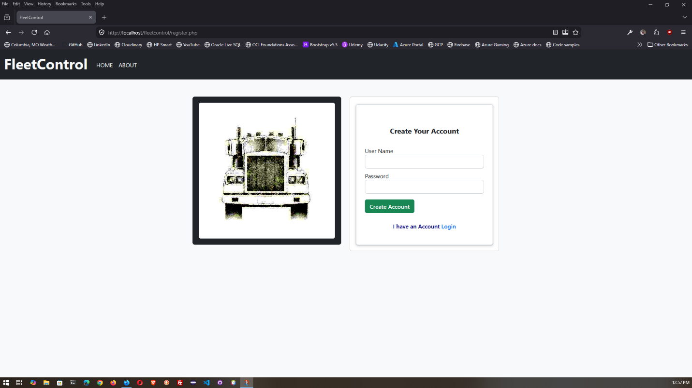
Figure 3: FleetControl Register Webpage

FleetControl Website Terms, Conditions, and Privacy Policy
Provide a graphic representation of each interface, for example, a low-resolution screenshot. Define all data elements associated with each screen or GUI, or reference the data dictionary.

Screen [x.3]
Provide a graphic representation of each interface, for example, a low-resolution screenshot. Define all data elements associated with each screen or GUI, or reference the data dictionary.

System Integrity Controls
System designers should give consideration to integrity controls in order to restrict the loss, misuse, modification of, or unauthorized access to information that could affect the company, client, or its customers.
With this in mind, ensure that the following minimum levels of control are included:
- Ability to identify audit information by user identification, network terminal identification, date, time, and data accessed or changed
- Audit procedures to meet control, reporting, and retention period requirements
- Controls to restrict access of critical data items
- Verification processes for additions, deletions, or updates of critical data

Appendix A
Attach any addition information that supplements the design specification.

Requirements Traceability Matrix
Include a Requirements Traceability Matrix that traces modules and data structures to the software requirements.

Packaging and Installation
Outline any special considerations for software packaging and installation.

Design Metrics
Describe all metrics to be used during the design activity.

Glossary of Terms
Identify all terms that establish meaning within the context of the plan.
Term | Meaning
Table 1 — Glossary of Terms

